**CHARTING THE COURSE OF INNOVATION: A STARTUP ANALYSIS**

* INTRODUCTION

**1.Overview**

A startup is a company in the early stages development that is a set up by one or several people to enter an existing market with unique products or services. Startup companies often face insufficient capital to fund their business operations to be at the same level as already established companies. As a result, the prime source of funding comes from the founder’s friends and families.

In their newness, startups usually focus on raising capital to further product development. Raising such fund is always needs to make a strong argument that supports the viability of its business idea. Some renowned startup companies include Airbnb, SpaceX, Avant, and Pinterest.

**2.Purpose**

The primary aim is to answer market demand by creating new and innovative products or services. While most small businesses might intend to stay small, a designated market. Usually, such companies start as an idea and gradually grow into a viable product, service or platform.

* PROBLEM DEFINITION & DESIGN THINKING

**1.Empathy Map**

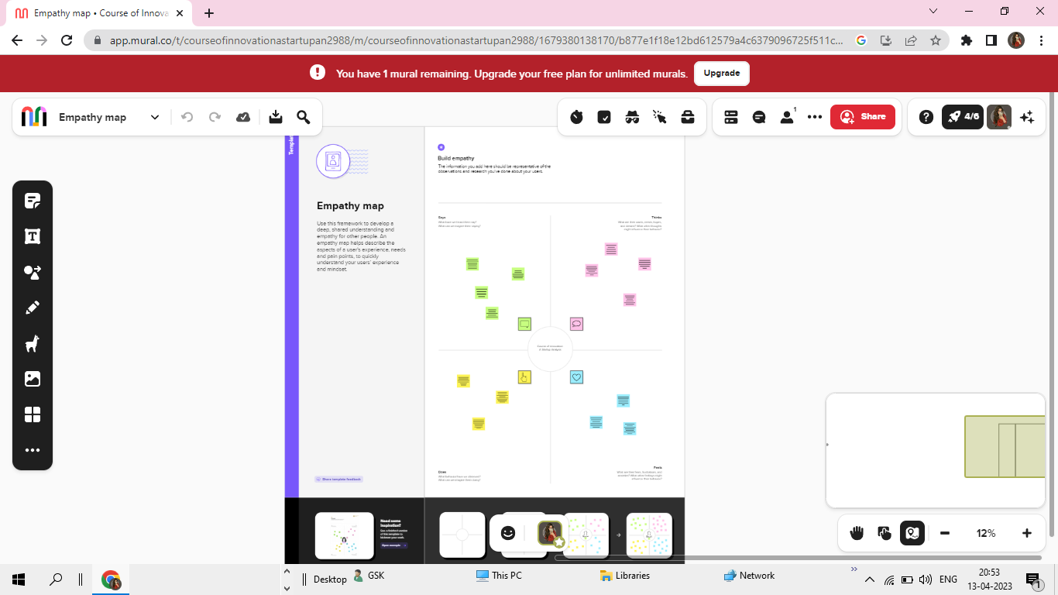

**2.Brainstorming & Ideation Map**

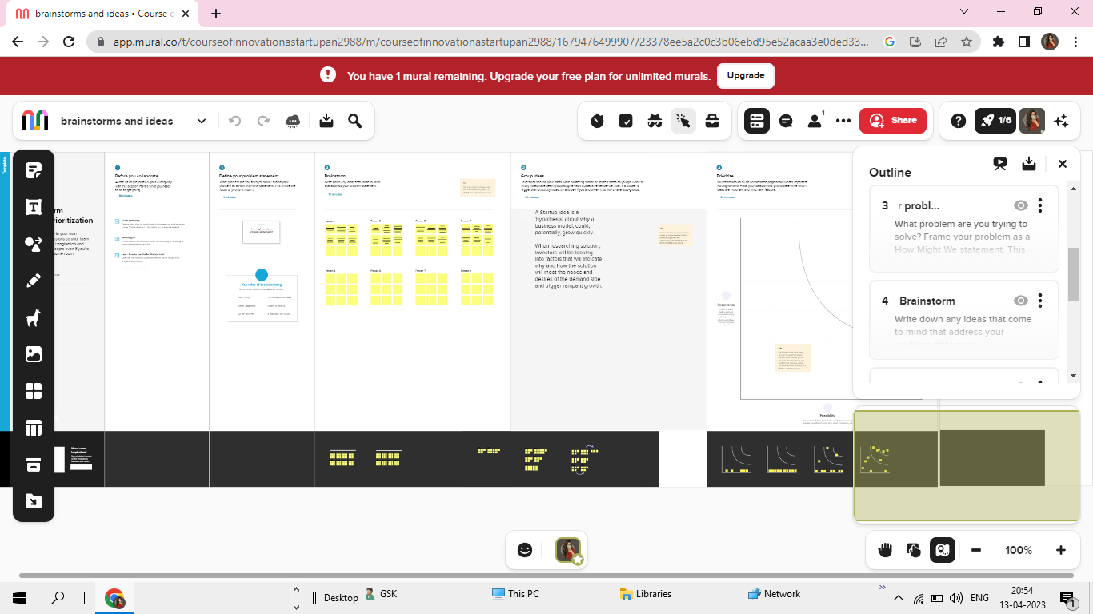

* **RESULT**

**Visualization, Dashboard and Story**

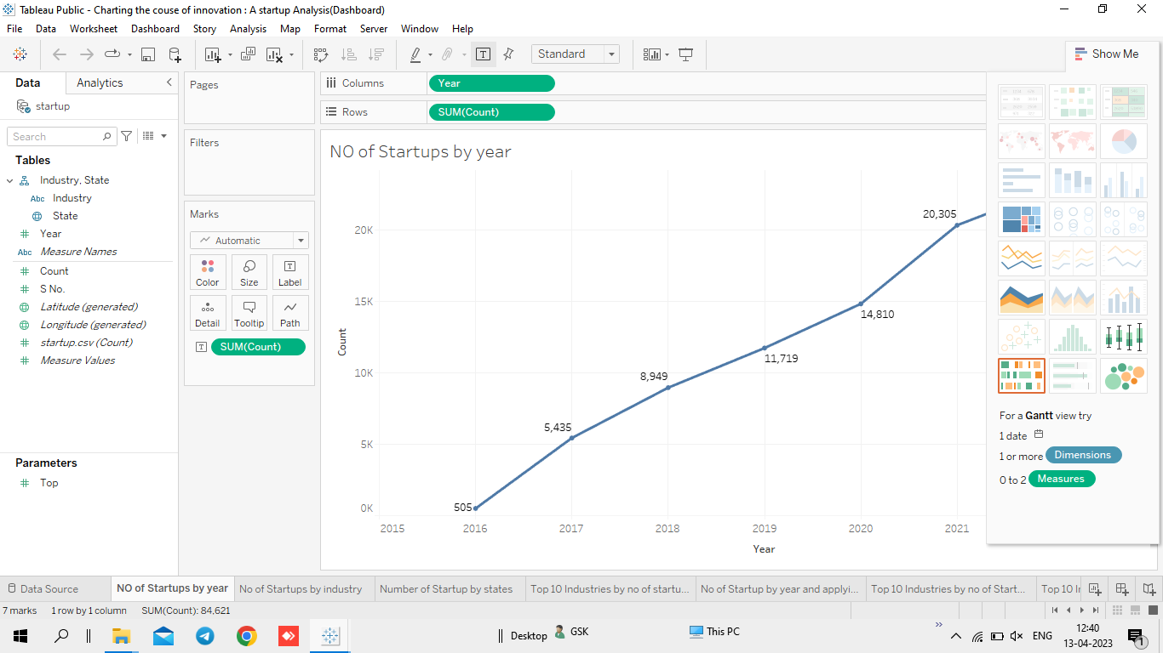

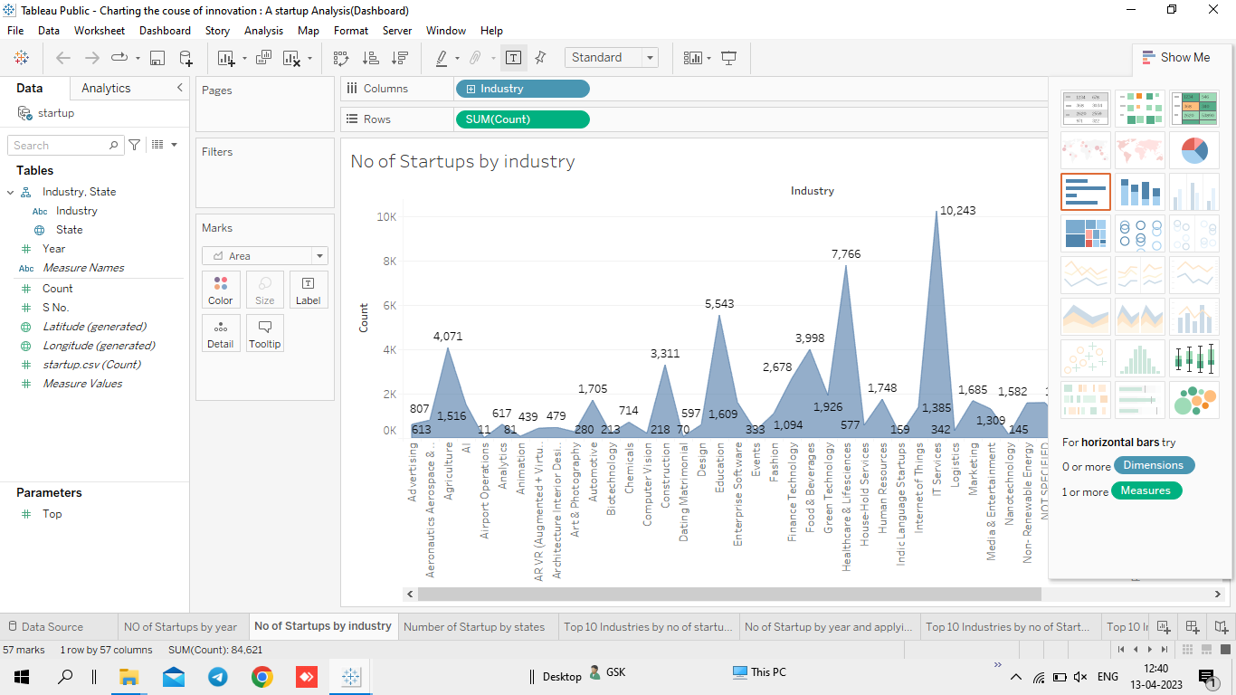

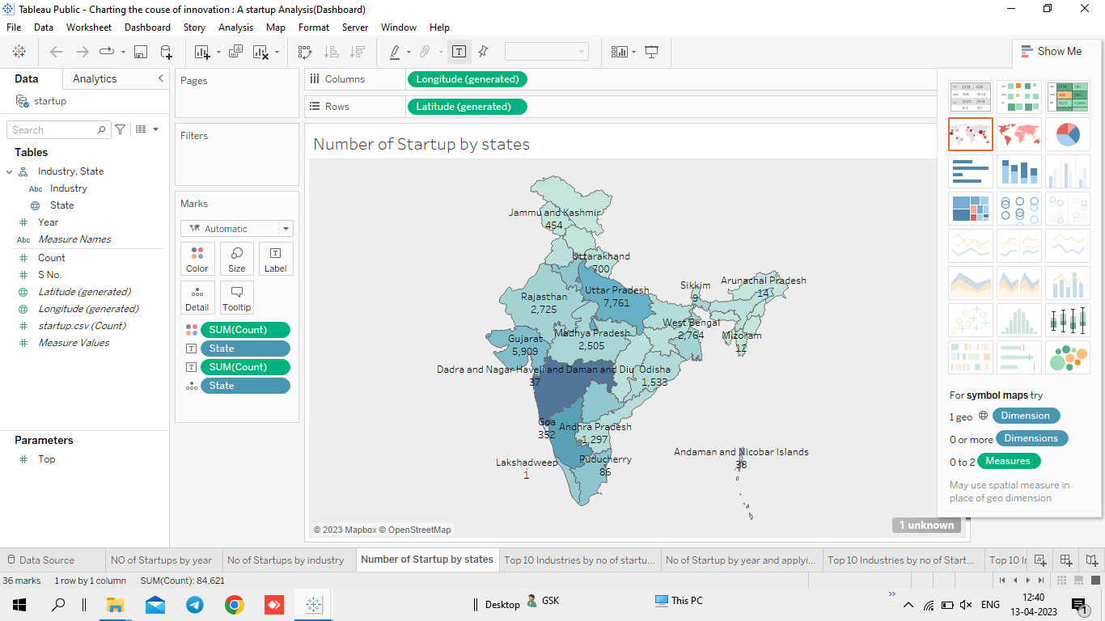

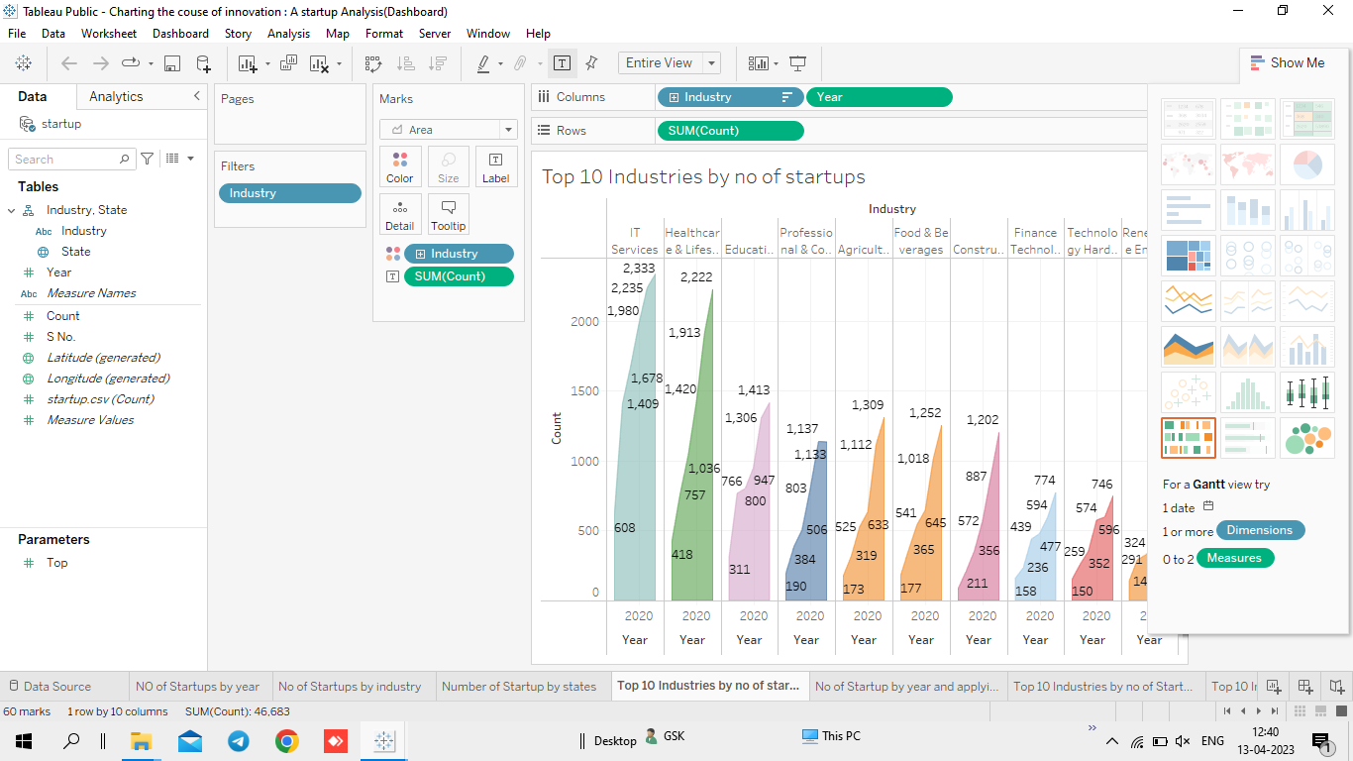

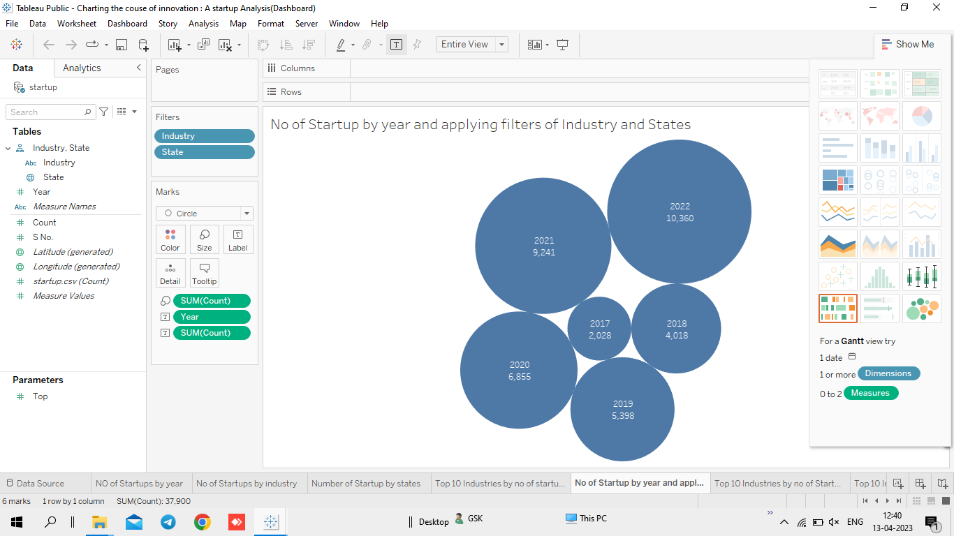

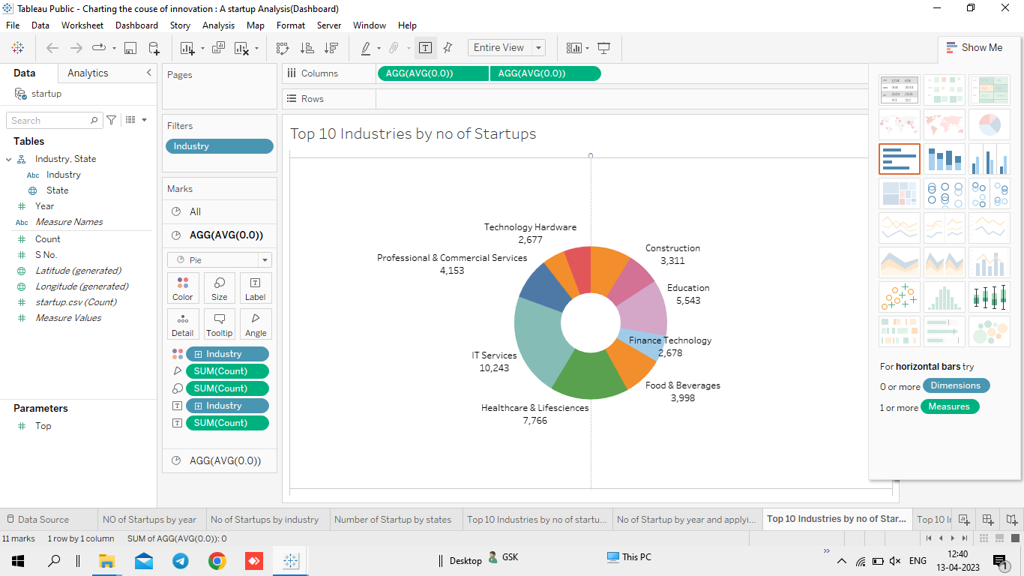

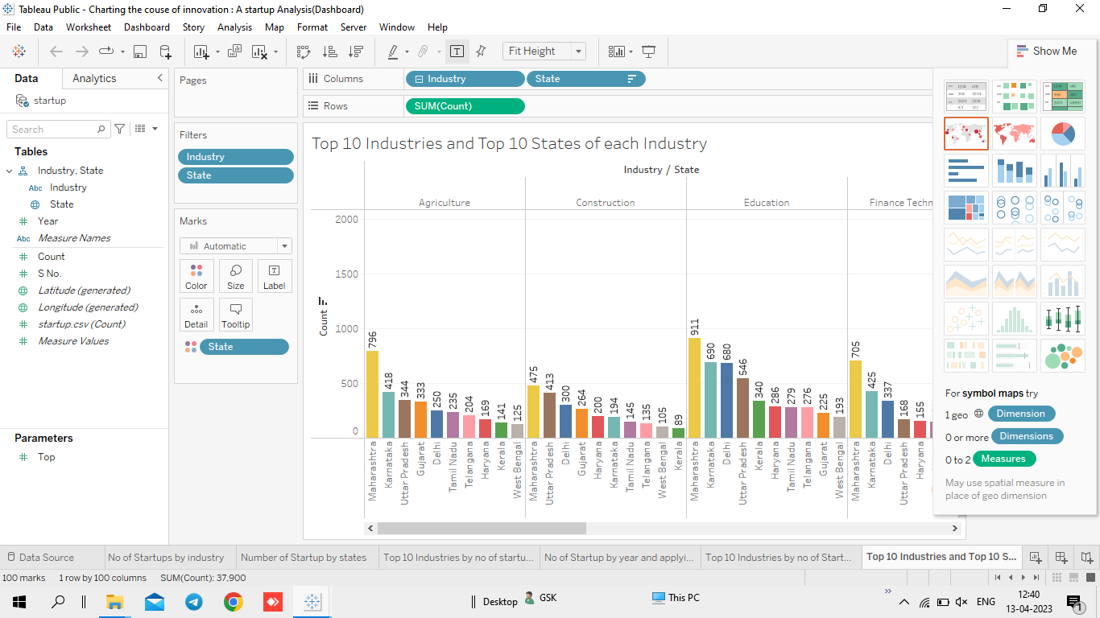

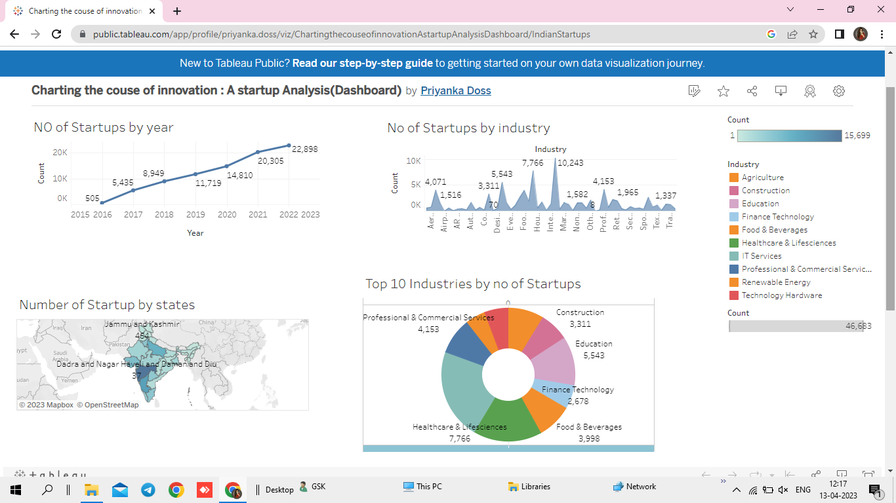

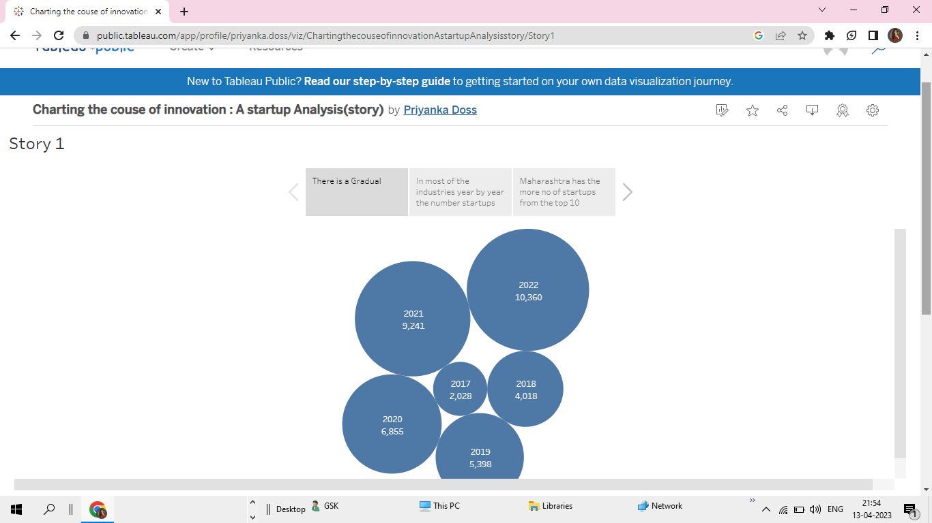

* **ADVANTAGES**
* Startups are smaller and less structured.
* They are also innovative and keep improving their business models, processes and portfolio.
* Startups deliver their products and services with a personal experience for their customers.
* Startups also take time to study and understand their customers business requirements.
* **DISADVANTAGES**

* Startup fails within their first year if operations, so the risk of failure is high.
* Working under such high risk can blur a startup’s strategic vision.
* It takes blood, sweat ad tears to build a company and long working hours are the norms for startups.
* Low consumption, many responsibilities and long working hours are more or less expected.
* **APPLICATIONS**

* It is used to asses a company’s long-term financial health and to make decisions about investment, growth and debt
* Financial analysis is a powerful tool that can help startups make informed decisions about their business.
* It is important to choose the right type of analysis for the decision you need to make.
* **CONCLUSION**

A business plan conclusion is a summary of a business plan’s strengths designed to convince the reader of the company’s success. Because companies typically create business plans to get funding or investors, the conclusion should focus on how the organization makes money and why it is a good investment.

* **SOURCE CODE FOR MY PROJECT**

<!DOCTYPE html>

<html lang="en">

  <head>

    <meta charset="utf-8" />

    <title>StartUp</title>

    <!-- mobile responsive meta -->

    <meta name="viewport" content="width=device-width, initial-scale=1" />

    <meta

      name="viewport"

      content="width=device-width, initial-scale=1, maximum-scale=1"

    />

    <!-- theme meta -->

    <meta name="theme-name" content="dtox" />

    <!-- ** Plugins Needed for the Project ** -->

    <!-- Bootstrap -->

    <link rel="stylesheet" href="plugins/bootstrap/bootstrap.min.css" />

    <!-- themefy-icon -->

    <link rel="stylesheet" href="plugins/themify-icons/themify-icons.css" />

    <!-- slick slider -->

    <link rel="stylesheet" href="plugins/slick/slick.css" />

    <!-- venobox popup -->

    <link rel="stylesheet" href="plugins/Venobox/venobox.css" />

    <!-- aos -->

    <link rel="stylesheet" href="plugins/aos/aos.css" />

    <!-- Main Stylesheet -->

    <link href="css/style.css" rel="stylesheet" />

    <!--Favicon-->

    <link rel="shortcut icon" href="images/favicon.ico" type="image/x-icon" />

    <link rel="icon" href="images/favicon.ico" type="image/x-icon" />

  </head>

  <body>

    <!-- navigation -->

    <section class="fixed-top navigation">

      <div class="container">

        <nav class="navbar navbar-expand-lg navbar-light">

          <a class="navbar-brand" href="index.html"

            ><img src="images/logo1.png" alt="logo" width="70" height="70"

          /></a>

          <button

            class="navbar-toggler border-0"

            type="button"

            data-toggle="collapse"

            data-target="#navbar"

            aria-controls="navbar"

            aria-expanded="false"

            aria-label="Toggle navigation"

          >

            <span class="navbar-toggler-icon"></span>

          </button>

          <!-- navbar -->

          <div class="collapse navbar-collapse text-center" id="navbar">

            <ul class="navbar-nav ml-auto">

              <li class="nav-item">

                <a class="nav-link" href="index.html">Home</a>

              </li>

              <li class="nav-item">

                <a class="nav-link" href="about.html">About</a>

              </li>

              <!-- <li class="nav-item">

                <a class="nav-link page-scroll" href="#feature">Feature</a>

              </li>               -->

              <li class="nav-item">

                <a class="nav-link" href="dashboard.html">Dashboard</a>

              </li>

              <li class="nav-item">

                <a class="nav-link page-scroll" href="story.html">Story</a>

              </li>

              <li class="nav-item">

                <a class="nav-link" href="contact.html">Contact</a>

              </li>

            </ul>

            <!-- <a href="#" class="btn btn-primary ml-lg-3 primary-shadow"

              >Try Free</a

            > -->

          </div>

        </nav>

      </div>

    </section>

    <!-- /navigation -->

    <!-- hero area -->

    <section

      class="hero-section hero"

      data-background=""

      style="background-image: url(images/hero-area/banner-bg.png)"

    >

      <div class="container">

        <div class="row">

          <div class="col-lg-12 text-center zindex-1">

            <h1 class="mb-3">

              Indian StartUp <br>

              Analysis and Visualization

            </h1>

            <p class="mb-4">

             We have anyalized and about the startups that are especially in India and approved by Indian Govt.

            </p>

            <a href="about.html" class="btn btn-secondary btn-lg">explore us</a>

            <!-- banner image -->

            <!-- <img

              class="img-fluid w-100 banner-image"

              src="images/hero-area/banner-img.png"

              alt="banner-img"

            /> -->

          </div>

        </div>

      </div>

      <!-- background shapes -->

      <div id="scene">

        <img

          class="img-fluid hero-bg-1 up-down-animation"

          src="images/background-shape/feature-bg-2.png"

          alt=""

        />

        <img

          class="img-fluid hero-bg-2 left-right-animation"

          src="images/background-shape/seo-ball-1.png"

          alt=""

        />

        <img

          class="img-fluid hero-bg-3 left-right-animation"

          src="images/background-shape/seo-half-cycle.png"

          alt=""

        />

        <img

          class="img-fluid hero-bg-4 up-down-animation"

          src="images/background-shape/green-dot.png"

          alt=""

        />

        <img

          class="img-fluid hero-bg-5 left-right-animation"

          src="images/background-shape/blue-half-cycle.png"

          alt=""

        />

        <img

          class="img-fluid hero-bg-6 up-down-animation"

          src="images/background-shape/seo-ball-1.png"

          alt=""

        />

        <img

          class="img-fluid hero-bg-7 left-right-animation"

          src="images/background-shape/yellow-triangle.png"

          alt=""

        />

        <img

          class="img-fluid hero-bg-8 up-down-animation"

          src="images/background-shape/service-half-cycle.png"

          alt=""

        />

        <img

          class="img-fluid hero-bg-9 up-down-animation"

          src="images/background-shape/team-bg-triangle.png"

          alt=""

        />

      </div>

    </section>

    <!-- /hero-area -->

    <!-- feature -->

    <section class="section feature mb-0" id="feature">

      <div class="container">

        <div class="row">

          <div class="col-lg-12 text-center">

            <h2 class="section-title">Awesome Features</h2>

            <p class="mb-100">

            </p>

          </div>

          <!-- feature item -->

          <div class="col-md-6 mb-80">

            <div class="d-flex feature-item">

              <div>

                <i class="ti-ruler-pencil feature-icon mr-4"></i>

              </div>

              <div>

                <h4>Awesome Design</h4>

                <p>

                  The Graphs aND Charts used in here for Visualization will be more understanding at a quick glance.

                </p>

              </div>

            </div>

          </div>

          <!-- feature item -->

          <div class="col-md-6 mb-80">

            <div class="d-flex feature-item">

              <div>

                <i class="ti-layout-cta-left feature-icon mr-4"></i>

              </div>

              <div>

                <div class='tableauPlaceholder' id='viz1681294937895' style='position: relative'><noscript><a href='#'><img alt='Indian Startups ' src='https:&#47;&#47;public.tableau.com&#47;static&#47;images&#47;Ch&#47;ChartingthecouseofinnovationAstartupAnalysisDashboard&#47;IndianStartups&#47;1_rss.png' style='border: none' /></a></noscript><object class='tableauViz'  style='display:none;'><param name='host_url' value='https%3A%2F%2Fpublic.tableau.com%2F' /> <param name='embed_code_version' value='3' /> <param name='site_root' value='' /><param name='name' value='ChartingthecouseofinnovationAstartupAnalysisDashboard&#47;IndianStartups' /><param name='tabs' value='no' /><param name='toolbar' value='yes' /><param name='static_image' value='https:&#47;&#47;public.tableau.com&#47;static&#47;images&#47;Ch&#47;ChartingthecouseofinnovationAstartupAnalysisDashboard&#47;IndianStartups&#47;1.png' /> <param name='animate_transition' value='yes' /><param name='display_static_image' value='yes' /><param name='display_spinner' value='yes' /><param name='display_overlay' value='yes' /><param name='display_count' value='yes' /><param name='language' value='en-US' /></object></div>                <script type='text/javascript'>                    var divElement = document.getElementById('viz1681294937895');                    var vizElement = divElement.getElementsByTagName('object')[0];                    if ( divElement.offsetWidth > 800 ) { vizElement.style.width='100%';vizElement.style.height=(divElement.offsetWidth*0.75)+'px';} else if ( divElement.offsetWidth > 500 ) { vizElement.style.width='100%';vizElement.style.height=(divElement.offsetWidth*0.75)+'px';} else { vizElement.style.width='100%';vizElement.style.height='1377px';}                     var scriptElement = document.createElement('script');                    scriptElement.src = 'https://public.tableau.com/javascripts/api/viz_v1.js';                    vizElement.parentNode.insertBefore(scriptElement, vizElement);                </script>

                <h4>Easy Customize</h4>

                <p>

                  The Dashboard that is created in the responsive and dynamic dahboard that you can use to analyze and understand more.

                </p>

              </div>

            </div>

          </div>

          <!-- feature item -->

          <div class="col-md-6 mb-80">

            <div class="d-flex feature-item">

              <div>

                <i class="ti-split-v-alt feature-icon mr-4"></i>

              </div>

              <div>

                <h4>Saving Time</h4>

                <p>

                  To start you startup, now need to keep hours of your time to just understand what the stage of all startups here you can understand quickly by just looking the Visualization.

                </p>

              </div>

            </div>

          </div>

          <!-- feature item -->

          <div class="col-md-6 mb-80">

            <div class="d-flex feature-item">

              <div>

                <i class="ti-layers-alt feature-icon mr-4"></i>

              </div>

              <div>

                <h4>Story</h4>

                <p>

                  The Narration of data based the Visualization and analysis is super engaging.

                </p>

                <div class='tableauPlaceholder' id='viz1681295021427' style='position: relative'><noscript><a href='#'><img alt='Story 1 ' src='https:&#47;&#47;public.tableau.com&#47;static&#47;images&#47;Ch&#47;ChartingthecouseofinnovationAstartupAnalysisstory&#47;Story1&#47;1_rss.png' style='border: none' /></a></noscript><object class='tableauViz'  style='display:none;'><param name='host_url' value='https%3A%2F%2Fpublic.tableau.com%2F' /> <param name='embed_code_version' value='3' /> <param name='site_root' value='' /><param name='name' value='ChartingthecouseofinnovationAstartupAnalysisstory&#47;Story1' /><param name='tabs' value='no' /><param name='toolbar' value='yes' /><param name='static_image' value='https:&#47;&#47;public.tableau.com&#47;static&#47;images&#47;Ch&#47;ChartingthecouseofinnovationAstartupAnalysisstory&#47;Story1&#47;1.png' /> <param name='animate_transition' value='yes' /><param name='display_static_image' value='yes' /><param name='display_spinner' value='yes' /><param name='display_overlay' value='yes' /><param name='display_count' value='yes' /><param name='language' value='en-US' /></object></div>                <script type='text/javascript'>                    var divElement = document.getElementById('viz1681295021427');                    var vizElement = divElement.getElementsByTagName('object')[0];                    vizElement.style.width='100%';vizElement.style.height=(divElement.offsetWidth*0.75)+'px';                    var scriptElement = document.createElement('script');                    scriptElement.src = 'https://public.tableau.com/javascripts/api/viz_v1.js';                    vizElement.parentNode.insertBefore(scriptElement, vizElement);                </script>

              </div>

            </div>

          </div>

        </div>

      </div>

      <img

        class="feature-bg-1 up-down-animation"

        src="images/background-shape/feature-bg-1.png"

        alt="bg-shape"

      />

      <img

        class="feature-bg-2 left-right-animation"

        src="images/background-shape/feature-bg-2.png"

        alt="bg-shape"

      />

    </section>

    <!-- /feature -->

    <!-- newsletter -->

    <section class="newsletter">

      <div class="container">

        <div class="row">

          <div class="col-lg-12 text-center">

            <h2>Subscribe to our newsletter</h2>

            <p class="mb-5">Receive updates, news and deals</p>

          </div>

          <div class="col-lg-8 col-sm-10 col-12 mx-auto">

            <form action="#">

              <div class="input-wrapper position-relative">

                <input

                  type="email"

                  class="newsletter-form"

                  id="newsletter"

                  placeholder="Enter your email"

                />

                <button type="submit" value="send" class="btn newsletter-btn">

                  subscribe

                </button>

              </div>

            </form>

          </div>

        </div>

      </div>

      <!-- background shapes -->

      <img

        class="newsletter-bg-shape left-right-animation"

        src="images/background-shape/seo-ball-2.png"

        alt="background-shape"

      />

    </section>

    <!-- /newsletter -->

    <!-- footer -->

    <footer

      class="footer-section footer"

      style="background-image: url(images/backgrounds/footer-bg.png)"

    >

      <div class="container">

        <div class="row">

          <div class="col-lg-4 text-center text-lg-left mb-4 mb-lg-0">

            <!-- logo -->

            <a href="index.html">

              <img

                class="img-fluid"

                src="images/logo1.PNG"

                alt="logo"

                width="70"

                height="70"

              />

            </a>

          </div>

          <!-- footer menu -->

          <nav class="col-lg-8 align-self-center mb-5">

            <ul class="list-inline text-lg-right text-center footer-menu">

              <li class="list-inline-item active">

                <a href="index.html">Home</a>

              </li>

              <li class="list-inline-item">

                <a class="page-scroll" href="#feature">Feature</a>

              </li>

              <li class="list-inline-item"><a href="about.html">About</a></li>

              <li class="list-inline-item">

                <a class="page-scroll" href="#team">Team</a>

              </li>

              <li class="list-inline-item">

                <a class="page-scroll" href="#pricing">Pricing</a>

              </li>

              <li class="list-inline-item">

                <a href="contact.html">Contact</a>

              </li>

            </ul>

          </nav>

          <!-- footer social icon -->

          <nav class="col-12">

            <ul class="list-inline text-lg-right text-center social-icon">

              <li class="list-inline-item">

                <a class="facebook" href="#"><i class="ti-facebook"></i></a>

              </li>

              <li class="list-inline-item">

                <a class="twitter" href="#"><i class="ti-twitter-alt"></i></a>

              </li>

              <li class="list-inline-item">

                <a class="linkedin" href="#"><i class="ti-linkedin"></i></a>

              </li>

              <li class="list-inline-item">

                <a class="black" href="#"><i class="ti-github"></i></a>

              </li>

            </ul>

          </nav>

        </div>

      </div>

    </footer>

    <!-- /footer -->

    <!-- jQuery -->

    <script src="plugins/jQuery/jquery.min.js"></script>

    <!-- Bootstrap JS -->

    <script src="plugins/bootstrap/bootstrap.min.js"></script>

    <!-- slick slider -->

    <script src="plugins/slick/slick.min.js"></script>

    <!-- venobox -->

    <script src="plugins/Venobox/venobox.min.js"></script>

    <!-- aos -->

    <script src="plugins/aos/aos.js"></script>

    <!-- Main Script -->

    <script src="js/script.js"></script>

  </body>

</html>